ANED 2014 Task 5 – European semester country fiche on disability

Country: Denmark

Author(s): Steen Bengtsson
With comparative data provided by the ANED core team

The Academic Network of European Disability experts (ANED) was established by the European Commission in 2008 to provide scientific support and advice for its disability policy Unit. In particular, the activities of the Network will support the future development of the EU Disability Action Plan and practical implementation of the United Nations Convention on the Rights of Disabled People.

This country report has been prepared as input for the Flash synthesis report on the European Semester.

Summary of the overall situation and challenges

When we look at the situation of people with disabilities in relation to the situation of people without disabilities in Denmark, we see that the relationship between the situations of the two groups is much the same as in the EU in general.

People with disabilities are employed to a lesser extent in Denmark than people without disabilities, exactly as is the case in other EU countries.
Likewise, people with disabilities are educated to a less extent in Denmark than people without disabilities, and relatively more people with disabilities are poor than people without disabilities.

There have the past ten years been ​​some efforts in the form of legislation to improve conditions for people with disabilities. Thus, there has been an active employment policy, which among other things has created a significant number of flexi jobs. New legislation has aimed to strengthen the education of people with disabilities. These actions do not seem to have changed the situation of people with disabilities significantly.

Reforms are underway in school and education areas. They intend that the children learn more and that the students will complete their studies faster. These reforms will probably not have much impact on people with disability. A third reform strengthens the integration in public schools. The extent of special education has increased over the years. The reform now reverses this trend and from school year 2014 much fewer children will receive special education, and many more are integrated into mainstream classes. There are preliminary reports of both success and failure of this reform.

Poverty grew in the 00s, mainly because of cuts in social assistance. These cuts were abolished by the new government in 2011, and poverty is not increasing as fast anymore. However, changes in unemployment benefit mean that a group now receives a lower benefit. In addition, a new social assistance reform means lower benefit for the less than 30 year olds. The reform in 2013 made ​​it nearly impossible to get a disability pension for persons under 40.

Even if the aim of these reforms is to get more people into jobs, an effect may be to increase the number of poor people with disabilities.

Assessment of the situation of disabled people with respect to the Europe 2020 headline targets

Strategic targets

Table 1: Europe 2020 and agreed national targets for the general population
 | Europe 2020 targets | National targets
Employment | 75% of the 20-64 year-olds to be employed | 80% of the 20-64 year-olds to be employed
Education | Reducing the rates of early school leaving below 10% | Reducing the rates of early school leaving below 10%
Education | At least 40% of 30-34–year-olds completing third level education | At least 40% of 30-34–year-olds completing third level education
Fighting poverty and social exclusion | At least 20 million fewer people in or at risk of poverty and social exclusion | At least 22 thousand fewer people in or at risk of poverty and social exclusion

Any relevant disability targets from national strategies or sources:
Employment:
The government’s Disability Policy Action Plan 2013 (Handicappolitisk handlingsplan 2013) mentions three initiatives which involve goals: The most concrete is a goal of establishing 13,500 new flexi jobs in the years to 2016. A number of these jobs shall be for people with much reduced work ability, and therefore experiments with flexi jobs bonus to companies that employ a person in flexi jobs in 10 hours or less per week have been launched.

The other initiatives concern municipal rehabilitation teams to ensure better coordination of municipal efforts, and a pool to try methods that can help people with reading and writing difficulties in employment.

Education:
The government’s Disability Policy Action Plan 2013 (Handicappolitisk handlingsplan 2013) mentions a number of tests that will be developed, which in turn will make it possible to set targets. It is a screening tool for language understanding, a dyslexia test across educational programs, and a test of numeracy difficulties. Furthermore, the possibility of setting up special classes in high school for students with Asperger's syndrome is made ​​permanent.

The National Reform Programme
The objectives of this program are not about increasing the opportunities for people with disabilities, but to strengthen the country's economy. Table 4.2 in NRP Denmark 2014 summarizes how much various reforms help to increase labour supply in the period 2013-2020. The reform of the anticipatory pension (ie disability pension) and flexi-jobs scheme contribute with +5,000 working years. This should be compared with demographic shifts that give -16,000 working years, the impact of other new reforms +22,000 working years, while the impact of earlier reforms is so much as +81,000 working years.

A note on the use of EU data
Unless specified, the summary statistics presented in this report are drawn from 2012 EU-SILC micro data. The EU-SILC sample includes people living in private households and does not include people living in institutions. The proxy used to identify people with disabilities (impairments) is whether ‘for at least the past 6 months’ the respondent reports that they have been ‘limited because of a health problem in activities people usually do’. Responses to this question vary between countries and national data sources are added for comparison, where available.

Table 2 shows the Prevalence of self-reported 'activity limitation' in Denmark and EU. It is well known that studies in Scandinavia find more disabled people than in the rest of Europe. The number of limited is larger, but the number of strongly limited smaller. The number of limited age 16-64 is larger, but the number of limited 65+ is very much smaller. All of these differences may primarily have cultural background. In Denmark the concept of disability is used broadly, but elderly people are keen about stressing that their abilities are intact.

Table 2: Self-reported ‘activity limitations’ as a proxy for impairment/disability (EU-SILC 2012)
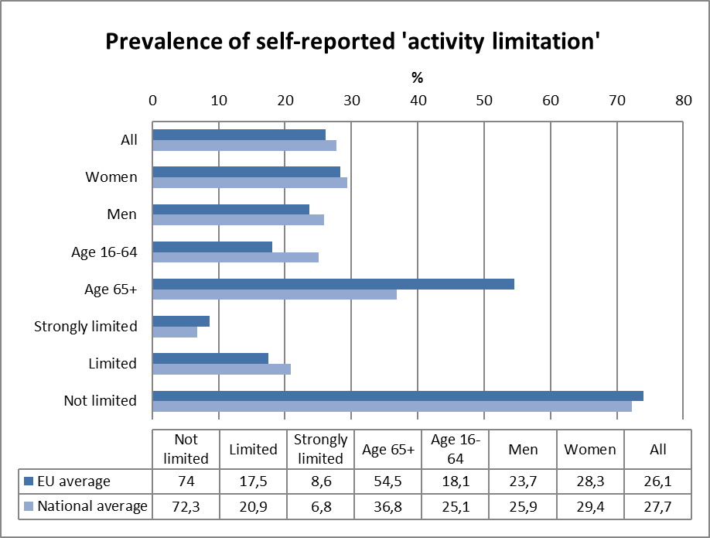
Source: EUSILC UDB 2012 – version 2 of August 2014

In subsequent tables, these data are used to estimate outcomes for ‘disabled’ people in the main target areas for EU2020 – employment, education and poverty risk. Due to the small number of observations for young people (aged 16-24) caution should be attached to interpreting results for this age group.

Alternative data on self-reported disability:
The survey SHILD conducted 2012 contains self-reported disability for the age group 16-64 years. The questions in SHILD are: Do you suffer from a long-term physical health problem or disability? And: Do you suffer from one or more mental disorders? As in all surveys, only few of the persons with intellectual disabilities are able to answer a lengthy questionnaire, and the survey does not cover this group.

SHILD finds 26 per cent with a physical disability and 9 per cent with a mental health problem, in total 30 per cent with a disability.
For women the numbers are 27 per cent with a physical disability, 11 per cent with a mental health problem, in total 33 per cent with a disability.

For men the numbers are 24 per cent with a physical disability, 7 per cent with a mental health problem, in total 28 per cent with a disability.

Employment data

Table 3: Most recent employment data, aged 20-64
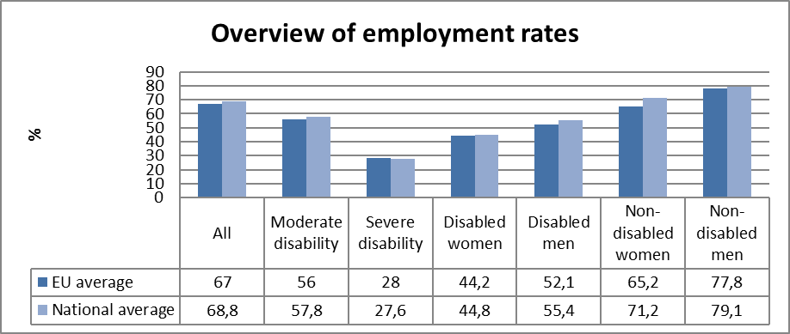

Table 4: Employment rate data, by age group
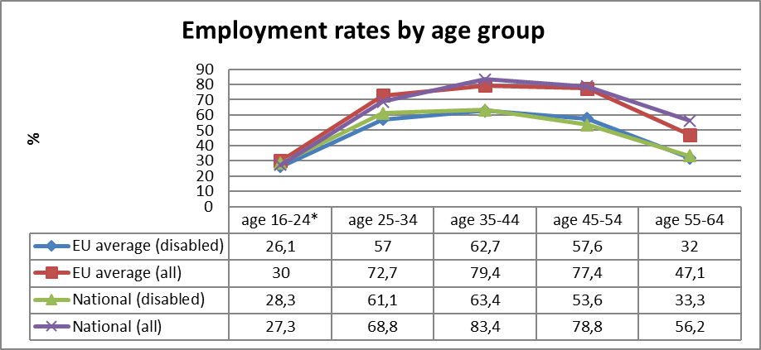
Table 5: comparison of data from EU-SILC (2012) and the LFS ad hoc disability module (2011)
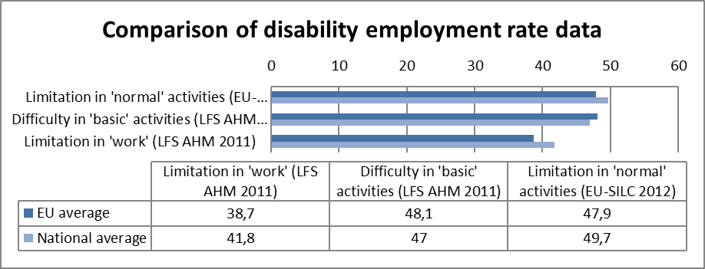
Source: EUSILC UDB 2012 – version 2 of August 2014, and Eurostat LFS AHM 2011

Table 6: Five-year trends in employment by gender and disability (aged 20-64)
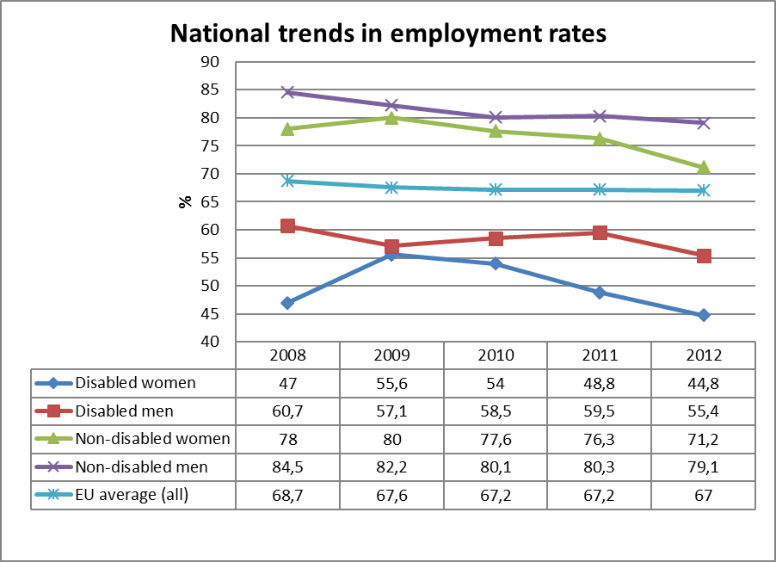
Source: EUSILC UDB 2012 – version 2 of August 2014 (and preceding UDBs)

Alternative data on disability and employment from national sources:
Some of the data in table 3 can be checked against the results from the work force surveys. They find for 2012 an employment rate for severely disabled people of 26.8 per cent, only 0.8 per cent points below the EU-SILC result. For moderately disabled people they find an employment rate of 67.1%, which is as much as 9.3% above the EU-SILC result. For non-disabled people they find an employment rate of 77.5%, which is about 2 per cent points less than the EU-SILC result.

The trends in table 6 are confirmed by the general result of the workforce surveys since they started covering disability in 2002, showing that the employment rate of people with disability has developed in parallel with the employment rate of people without disability.

Unemployment

National administrative rules and definitions of ‘unemployment’ may affect the way in which people with disabilities are categorised in different countries.

Table 7: Most recent unemployment data, aged 20-64
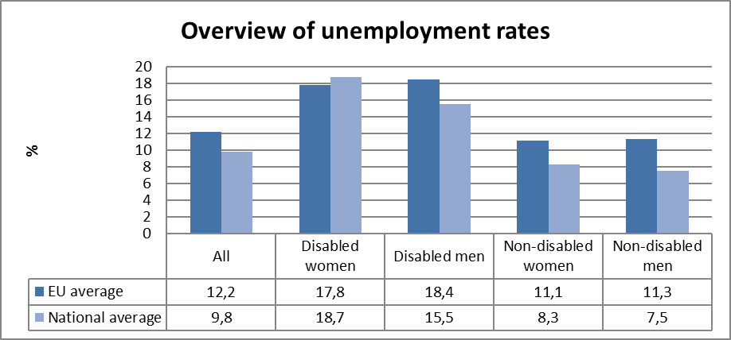
Source: EUSILC UDB 2012 – version 2 of August 2014

Table 8: Unemployment rate data, by age group
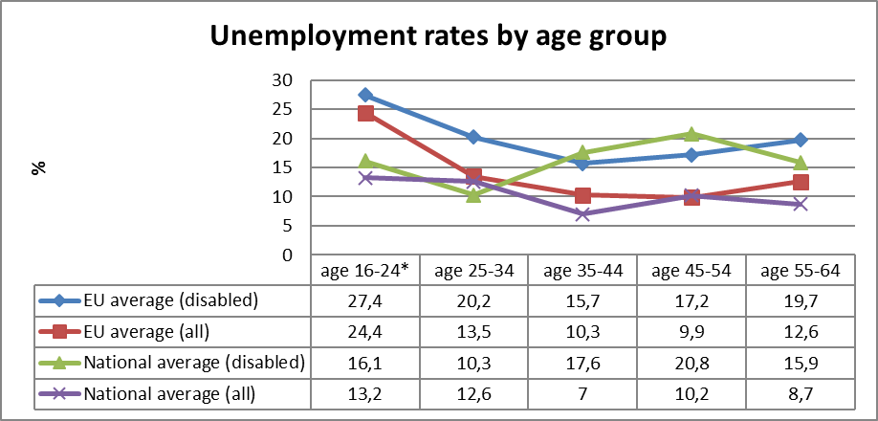
Source: EUSILC UDB 2012 – version 2 of August 2014

Alternative data on disability and unemployment from national sources:
No alternative data.

Economic activity

Table 9: Most recent economic activty data, aged 20-64
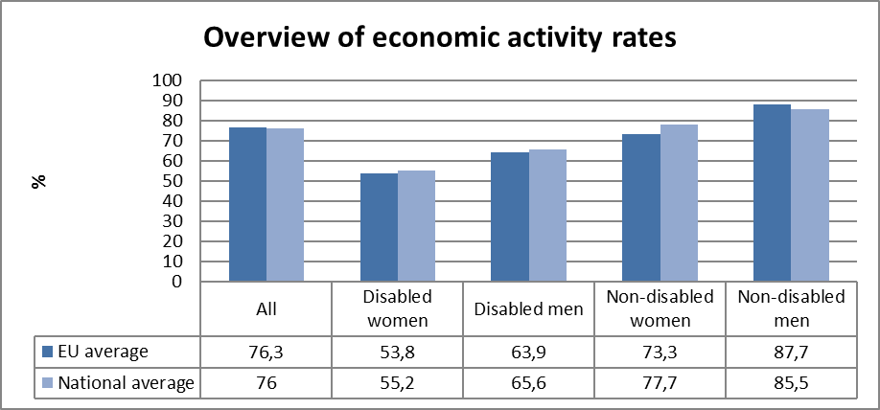
Source: EUSILC UDB 2012 – version 2 of August 2014
Table 10: Activity rate data, by age group
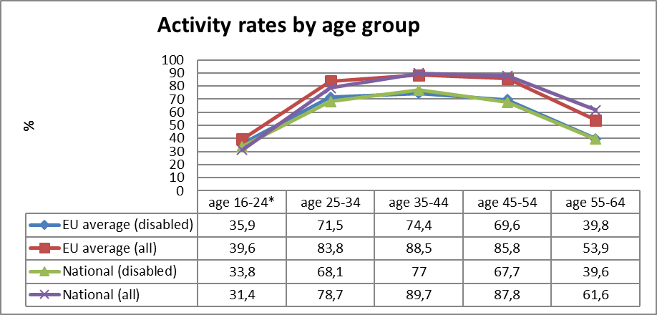
Source: EUSILC UDB 2012 – version 2 of August 2014

Alternative data on disability and economic activity from national sources:
No alternative data.

Education data

EU statistical comparisons are more limited concerning the education of young women and men with disabilities in the EU2020 target age groups. Data is available from EU-SILC (annually) as well as the Eurostat Labour Force Survey ad-hoc disability module (for 2011), but with low reliability for several countries on the key measures. Using wider age range can improve reliability but estimations by gender remain indicative. EU trends are evident but administrative data may offer more reliable alternatives to identify national trends, where available.

Early school leavers

The EU-SILC sample for the target age group (aged 18-24) includes the following number of people reporting activity ‘limitation’ (as a proxy for impairment/disability).

Table 11: EU-SILC sample size in the target age group 18-24
 | No activity ‘limitation’ | Activity ‘limitation’ | Women reporting ‘limitation’ | Men reporting ‘limitation’
EU sample | 37,438 | 2,693 | 1,338 | 1,355
National sample | 322 | 62 | 32 | 30
Source: EUSILC UDB 2012 – version 2 of August 2014
Table 12: Early school leavers aged 18-24 (indicative based on above sample size)
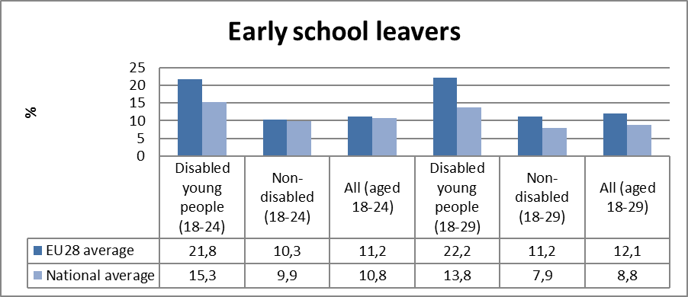

Alternative data on disability and early school leavers from national sources:
No alternative data.

Tertiary education

The EU-SILC sample for the target age group (aged 30-34) includes the following number of people reporting activity ‘limitation’ (a proxy for impairment/disability).

Table 13: EU-SILC sample size for the target age group 30-34
 | No activity ‘limitation’ | Activity ‘limitation’
EU sample | 25,596 | 2,801
National sample | 226 | 55

Table 14: Completion of tertiary or equivalent education (indicative based on above sample)
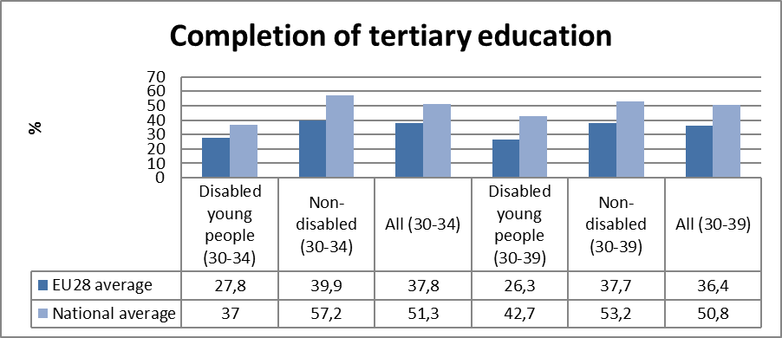
Source: EUSILC UDB 2012 – version 2 of August 2014

Alternative data on disability and tertiary education from national sources:
No alternative data.

Poverty and social exclusion data

EU SILC data provides indicators of the key risks for people with disabilities. In addition to household risks of low work intensity, there are risks of low income (after social transfers), and material deprivation. These three measures are combined in the overall estimate of risk. The risks for older people do not include work intensity (Eurostat refers to the age group 0-59 for this measure). The survey does not distinguish ‘activity limitation’ (the proxy for impairment/disability) for children under the age of 16. Relevant data from national sources is added where available.

Table 15: People living in household poverty and exclusion by key risk (aged 16-59)
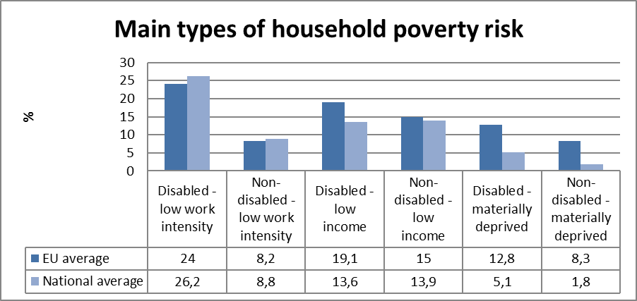
Source: EUSILC UDB 2012 – version 2 of August 2014

Table 16: People living in household poverty and exclusion by gender and severity (aged 16+)
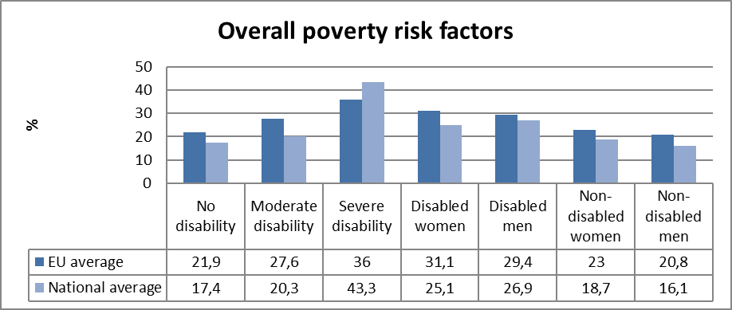
Table 17: Overall risk of household poverty by main age group (all, aged 16+)
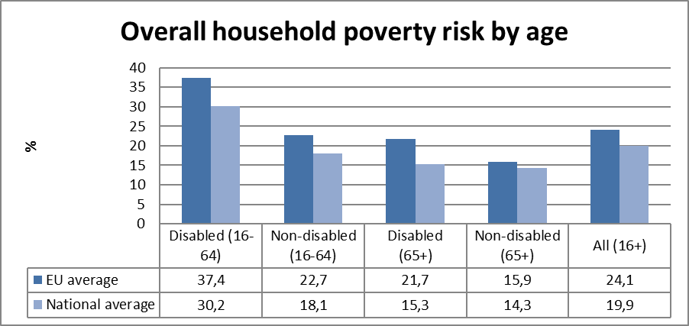
Source: EUSILC UDB 2012 – version 2 of August 2014

Table 18: Three-year trend in overall household risk of poverty and exclusion (EU-SILC 2012)
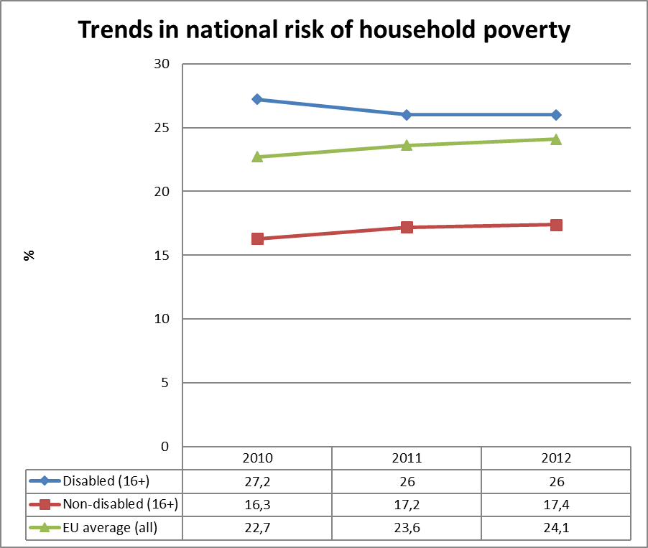
Source: EUSILC UDB 2012 – version 2 of August 2014 (and previous UDB)

Alternative data on disability and poverty risks from national sources:
A publication from Statistics Denmark about Danish living conditions puts particular focus on the measurement of poverty.

Statistics Denmark gives both the Eurostat and the OECD measure for "at risk of poverty". Eurostat defines this as the proportion of the population with a disposable income of less than 60 per cent of median income. OECD uses a threshold of 50 per cent of median income. With the Eurostat measure, 12.4 per cent were at risk of poverty in 2010. That figure is considerably lower than the EU-SILC result of 20 per cent.

Considering the Eurostat definition over time, 2.6 per cent were at risk of poverty for at least 5 years in a row. Combining the "risk of poverty" with a goal for to whether there are goods people cannot afford (so-called material deprivation), and whether they have a very low employment (so-called low work intensity), it turns out that 9.6 per cent are "at risk of poverty", have "material deprivation" and "low work intensity" (Eurostat definition).

When Statistics Denmark asked the Danes for their own assessment of their economic situation, results showed that 5 per cent have difficulty and 4 per cent find it very difficult to get money while half find it easy (22 per cent) and very easy (28 per cent).

Statistics Denmark gives the distribution of income relative to the poverty limit of Eurostat for groups defined by occupation and income. This figure shows that the incomes of pensioners are lower that the incomes of persons in employment, but at the same time the variance in the distribution is much less. For this reason, there are not any considerably large proportion of pensioners (including disability pensioners) who are below the poverty limit.
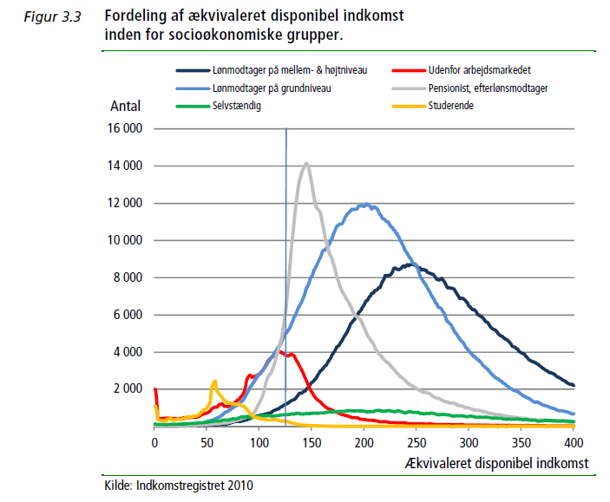
(the mentioned publication, p 33)
Lønmodtager = employed, grundniveau = low level, pensionist = pensioner

Description of the situation and trends in relation to each target area

Employment

Table 3 shows that severely disabled people have the same employment rate in Denmark as in EU overall, while moderately disabled people have a little larger, and non-disabled people a somewhat larger amount of employment. The Danish variation with age in table 4 is nearly the same as for the EU, except that more Danes without disabilities in the age group 55-64 are employed. Table 5 shows that some more Danes, who have limitations in work and in normal activities, are employed.

Table 6 shows that the 5-year trend in employment rates for disabled men in Denmark is nearly parallel to the corresponding trend for non-disabled men, and that the 5-year trend in employment rates for disabled women in Denmark is nearly parallel to the corresponding trend for non-disabled women. This development pattern has been found in the workforce surveys since 2002.

As table 7 shows, unemployment rates are lower in Denmark compared to EU in all groups except for disabled women, where it is larger. This is a surprising result, which should be controlled against larger surveys such as SHILD, as it may be due to the small sample in EU-SILC.

For the EU, unemployment rates for disabled persons are consistently above the unemployment rates for non-disabled persons in every age group. For Denmark, the picture is more complicated. For younger age groups, unemployment rates are low both for disabled and non-disabled persons. For the age groups from 35 and above, unemployment is much larger for disabled than for non-disabled persons. This is also a remarkable pattern, which should be controlled for and analysed with larger data.

As the unemployed is a small group, part of this fluctuation may be due to small numbers for Denmark, whereas the numbers for EU are considerably larger. It may also be an explanation that many young people with disabilities in Denmark are in education. The new employment policy aims precisely to motivate young people who have limitations with regard to work, to start an education.

Table 9 shows that economic activity rates for disabled women and men are around 1.5 per cent points larger in Denmark compared to the EU. Activity rates by age group are nearly identical for disabled people in Denmark and the EU. For non-disabled people, the younger age group has lower activity rates and the older have larger activity rates in Denmark.

The employment of people with disabilities in relation to the employment of people without disabilities has been studied systematically every few years in Denmark since 2002. The studies have shown that the employment of people with disabilities is lower than the employment of people without disabilities. A development that is determined by economic conditions can be seen in both employment rates, but they go together, and the relationship between them remains constant. There is a little more variation in the numbers of people with disabilities because they are smaller, but no systematic trend in the relationship between the two rates.

Education

Table 12 shows that Denmark has fewer early school leavers with disabilities.
Table 14 shows that Denmark has more people that have completed tertiary education, both among people with disabilities and among people without disabilities.

The EU-SILC surveys suggest that people with disabilities in Denmark are relatively well educated compared to the situation in the EU as a whole. There are fewer early school leavers among people with disabilities in Denmark, while the share of early school leavers among non-disabled people is roughly the same as in the EU in general. There are more people with tertiary education in Denmark than in the rest of EU, both among people with disabilities and among people without disabilities

Poverty and social inclusion

Table 15 shows that poverty risk is less for disabled people, but larger in households with low work intensity (including disabled people) in Denmark compared to EU.

Table 16 shows that the poverty risk is larger for people with severe disability in Denmark compared to the EU, but smaller for people with moderate or no disability.

Table 17 shows that the poverty risk is smaller across age groups in Denmark compared to EU.

Table 18 shows that the trend in poverty risk has been increasing in EU. The corresponding trend for people without disabilities has been increasing in Denmark as well, although at a slower rate. For disabled people, the trend in Denmark has been slightly decreasing.

The EU-SILK figures on poverty show that the number of poor people in general is lower in Denmark than it is in the EU as a whole. This pattern is also found for most subgroups that the population can be divided into. However, there is very little difference in the poverty risk between Denmark and the EU for non-disabled people over 64 years (table 17). Furthermore, the poverty risk is slightly higher in Denmark than in the EU in households with low work intensity (table 15), and somewhat higher when there are people with disabilities in these households. Finally, the risk of poverty is considerably higher for people with severe disability in Denmark compared to the EU in general (table 16).

The number of poor is growing in the EU in recent years (table 18), and it has also been so in Denmark, albeit at a slower pace. In Denmark, however, we see that the number of people with disabilities who are poor, is slightly decreasing.

Assessment of policies in place to meet the relevant headline targets

Employment

For some decades, the government has been pursuing a policy aiming to employ more people with disabilities. Thus, the number of flexi jobs has been augmented significantly since 2000. The policy has also aimed to inform enterprises about the support schemes available, and to get them to function more smoothly.

The impact of these efforts has been that more companies and employees are aware of the schemes, and the attitude to hire people with disabilities has become more open both for companies and for employees. But in the employment rate we have no corresponding development.

Thus the effect has been a verbalisation of employment of disabled people and that people with disabilities to a higher degree have come into special forms of employment such as flexi jobs, but not that a larger number of disabled people have moved into employment.

Education

The situation with regard to education for disabled people may change in the coming years as a result of two reforms in the primary education field. One of these reforms is discussed in detail in the National Reform Programme. It covers inter alia the introduction of all-day schools and improvement in the teaching of mathematics, English and Danish. The establishment of study cafes in schools so that the children of non- academic parents get more chances to keep up with school subjects is also part of the reform. This reform is likely to affect the level of education as a whole.

The second reform in primary schools is not mentioned in the National Reform Programme. The second reform deals directly with the increasing integration of pupils with special needs in mainstream classes. Over the past decade there has been a steady increase in the number of children who are referred into special need classes in Denmark, and a large proportion of the education budget has been spent on special needs education. The reform will try to turn around this development. From the school year 2014, a large number of school children who previously attended special needs classes have been integrated into regular classes. There are no evaluations of this reform. The press, however, has discussed both positive and negative experiences with the process.

The National Reform Programme also mentions a reform of study grants (SU). The SU-reform aims to make study time more effective and to shorten the studies. It does not directly address people with disabilities and the existing scheme of disability-SU. But it is possible that a general abbreviation of education time for the majority will entail that more students with minor disabilities will apply for disability-SU for the purpose of getting an extended study time.

Poverty and social inclusion

The number of poor people in Denmark has doubled from 2002 to 2012. The growth has however been slow from 2011 to 2012. Half of the poor are single persons, primarily men. One fourth is children. The number of poor children has nearly doubled too, but decreased a little 2011-2012. Immigrants from non-western countries account for a third of the poor, but only 6.5 per cent of the population in 2012. The analyses use a relative poverty concept like the EU. With an absolute poverty limit the number of poor people would remain constant for the period.

The main reasons for the growth in poverty for the period 2002-2011 has been the ceiling of social assistance (kontanthjælpsloft), the requirement of work for both partners in a couple to get social assistance (300 (450)-timers reglen) and reduced social assistance for immigrants (starthjælp) which was in force until 2011. These laws all reduced social assistance (kontanthjælp) for large groups of people, many of whom were immigrants.

Despite these legislative changes in 2011, the number of poor has probably not gone down. In 2011 unemployment benefit was shortened from 4 to 2 years, which had effects from 2012. Since then the government has tried to collect as many as possible of the people who have lost their right to unemployment benefits, by the means of temporary arrangements that provide them with less support.

A reform of social assistance (kontanthjælpsreform) in force 1.1 2014 replaced social assistance for persons below 30 years who do not have an education with an education benefit (uddannelsesydelse), which is at the level of study support (SU) and considerably lower than social assistance. The aim is to get more young people educated and in job, but it will no doubt also create more poor.

The reform of disability pension from 2013 had the same aim. The disability pension reform made it almost impossible for persons under 40 years to get a disability reform. Instead is now made a more intensive effort on education and rehabilitation where the benefit is lower.

It is not clear what the two reforms will mean for people with disabilities. Both reforms have aimed to fewer people being recipients of aid and more to come into jobs. If successful, it's fine. If this fails, the reforms will only lead to a greater number of people with disabilities to live with a very low benefit. It will mean relatively more people with disabilities among the poor.

Synergies between developments in the different areas

The overall line in Danish policy under this government as well as the former one has been to increase the work force in the hope of a coming economic recovery. Since this recovery has been long in coming, the policy has not yet had the desired effects.

The Danish reforms these years are all lined to the concept of the competition state. The purpose is to make the Danish economy more competitive and thus produce greater value so that there are more funds for social purposes. However, it is not certain that this policy can be implemented without leading to greater inequality. It has been the trend in recent years. There is a risk that greater inequality will hit people with disabilities disproportionately.

Very little is known of the policies’ combined effect for people with disabilities, and analyses of the development are really needed.

Follow-up of the disability perspective in the European semester

Progress on disability issues in the Country Specific Recommendations (CSRs)

Policy recommendation 2:
Take further measures to improve the employability of people at the margins of the labour market. Improve educational outcomes, in particular for young people with a migrant background, and the effectiveness of vocational training. Facilitate the transition from education to the labour market, including through a wider use of work-based training and apprenticeships.

Table 19: Policy measures related to achieving Recommendation 2
Policy Measure
An employment reform has been agreed. Repeated activation will be abolished, and ordinary education prioritised. Periods of wage subsidies will be reduced.
If a person becomes unemployed, she or he must within two weeks come to an interview related to the unemployment fund. Their CV should be approved and they should begin to make a personal plan. Within three to six weeks there will be an interview at the job center, with the participation of the unemployment fund. Here the personal plan for how to get a job is completed.
During the first six months there will be an interview at the job center every month. After six months, the unemployed person will come into activation. It will be a shorter period than that in place today. For example, it may be job training in a private company not exceeding four months.
If the unemployed person still has not got a job, she or he will get a more intensive effort at the end of the unemployment spell. She or he can for example have a personal job coach
Exact date of adoption
1.1.2015
Budget allocation
Existing budgets
Stage of implementation
Is an independent evaluation planned?
Assessment of impacts in relation to the CSRs
As the support for the unemployed persons with problems other than unemployment is strengthened, the chances should be expected to be improved for persons with mental health problems.
Ambition sufficient to meet CSRs?
As the CRS only consists in improvement, the answer must be yes.
Credibility?
Reasonable.

Other CSRs (not disability-specific) with a potential disability perspective/angle

No.

Assessment of disability relevant issues in the Staff Working Document (SWD)

There are no such issues.

Assessment of the structural funds 2007-2013 / ESIF 2014-2020 or other relevant funds

Use of funds in relation to disability challenges

Out of 18 projects in Denmark which have got EU support, 8 concern environmental problems, 5 economic growth, 4 local communities and 1 gender problems.

One of the environmental projects concerns building standards. It contains “an effort to introduce new, innovative and higher standards when it comes to energy efficiency, sustainability, resource-saving buildings and low lifecycle costs”. However there is nothing about disability.

Two of the growth projects are placed in North Jutland. It is the region with highest employment rate of people with disabilities. This is, however, not a concern of the projects. The same thing can be said of the other EU projects in Denmark.

Preparations for ESIF 2014-2020

There are no projects that are concerned with inclusion of people with disabilities in this term.

Recommendations

It is recommended that the development of the living conditions for people with disabilities in Denmark should be analysed more closely compared with now, where the cross-sectional analysis of EU countries makes it possible to detect differences between the countries and between groups of people that we would not otherwise be aware of.

Competition - based state reforms aim to replace former providence benefits with lower education or rehabilitation benefits that motivate the person to start an education or come into an internship. It is uncertain whether this mechanism can work in practice. Hence, a recommendation is made to follow the evolution of poverty in Denmark, and in this context shed light on whether poverty is increasingly going to hit people with disabilities.

http://ec.europa.eu/europe2020/pdf/targets_en.pdf.
Handicappolitisk handlingsplan kort fortalt, p 11, p 8. Visited 17.10.2014 on: http://sm.dk/filer/arbejdsomrader/handicap/handicappolitisk-handlingsplan-2013-kortfortalt.pdf.
EUSILC UDB 2012 – version 2 of August 2014.
The SILC survey questions are contained in the Minimum European Health Module (MEHM) http://epp.eurostat.ec.europa.eu/statistics_explained/index.php/Glossary:Minimum_European_Health_Module_(MEHM).
The methodology is further explained in the annual statistical reports of ANED, available at http://www.disability-europe.net/theme/statistical-indicators.
Damgaard, M, T Steffensen & S. Bengtsson: Hverdagsliv og levevilkår for mennesker med funktionsnedsættelser. (Living conditons for people with disabilities). København: SFI report 13:26.
Kjeldsen, MM, HS Houlberg & J Høgelund: Handicap og beskæftigelse. Udviklingen mellem 2002 og 2012. (Disability and employment. The development 2002-2008). København: SFI report 13:01.
For the LFS AHM data see, Early school leavers http://appsso.eurostat.ec.europa.eu/nui/show.do?dataset=hlth_de010&lang=en and tertiary educational attainment http://appsso.eurostat.ec.europa.eu/nui/show.do?dataset=hlth_de020&lang=en.
Statistics Denmark: Levevilkår. Tema: Måling af fattigdom. (Living conditions: Theme: Measurement of poverty). TemaPubl 2012:2.
Kjeldsen, MM, HS Houlberg & J Høgelund: Handicap og beskæftigelse. Udviklingen mellem 2002 og 2012. (Disability and employment. The development 2002-2008). København: SFI report 13:01.
Many of the results are summarized in the last survey in the series, Kjeldsen, MM, HS Houlberg & J Høgelund: Handicap og beskæftigelse. Udviklingen mellem 2002 og 2012. (Disability and employment. The development 2002-2008). København: SFI report 13:01.
According to an analysis from the think-tank Kraka: Analyse Kraka 27. Marts 2014. http://www.kraka.org/sites/default/files/public/antallet_af_fattige_i_danmark_steg_svagt_i_2012.pdf.
http://ec.europa.eu/regional_policy/projects/stories/search.cfm?LAN=EN&pay=DK&region=ALL&the=ALL&type=ALL&per=2.

